Laolao Bay Conservation Action Plan 2012 Addendum and Workplan

2012 CAP Process & Implementation
On February 28th, 2012, a working group met at the Pacific Islands Club on Saipan for a day-long workshop to review the Laolao Bay Conservation Action Plan created in 2009 and create a work plan for the 2012-2013 calendar years. Members of participating agencies for the original CAP as well as several new stakeholders were invited (see appendix for list of attendees). The objectives for the workshop were to update what projects and strategic actions had been accomplished, update monitoring outcomes, and establish new objectives and strategic actions for the 2012 and 2013 fiscal years. Deliverables were to include this addendum to the 2009 CAP which includes revised threat rankings, conceptual diagrams and results chains generated in Miradi and a list of 2012-2013 Objectives and Strategic actions.
Participants in the workshop agreed that regular evaluation and monitoring is necessary to continue to have management success in the Laolao Bay watershed. It was therefore decided that a review would be conducted every two years to evaluate the CAP (the next review is scheduled for early 2014) and that a meeting would occur annually to update the status of projects within the two-year workplan. The next workplan update meeting should occur in early 2013.

Objective, Strategic Action and Target Updates

Projects Complete/In Progress

ARRA Engineering, Road Development and Outreach
A $2.6 million grant was awarded through the American Recovery and Reinvestment Act to reduce erosion and sediment transfer from the Dandan/San Vicente side of Laolao Bay Drive through road and drainage improvements. The project is nearly complete at the writing of this addendum. The upper reach of the road (0.4 miles) was paved and storm water runoff controls were installed, redirecting these waters into a large sediment chamber at the bottom of the road. The remainder of the Laulau Bay Drive gravel road and the road leading to the dive site from the village of Kagman (Gap Gap Road) has been re-graded to improve drainage and decrease erosion. Workshops were held in 2010 and 2011 to discuss maintenance and construction of unpaved roads. These workshops were attended by government agency engineers and commercial contractors as well as the Public Works Department (responsible for government road maintenance) in an effort to improve regular maintenance to Laolao Bay drive and other unpaved roads on the island. Additionally, an engineering design plan was created for the eventual paving and re-alignment of Gapgap Road, the suspected main driver of sedimentation near the Laolao dive site. Construction costs for this road are estimated to be around $900,000 and the new road would be rerouted to more naturally follow the contour of the land and decrease erosion. Stream crossings along the unpaved portion of the road will also be hardened in 2012 at six locations to prevent chronic erosion. There are three additional stream crossings that are not on public easements and will therefore not be improved since property lease holders do not want permanent structures at those locations.

There has been significant progress revegetating the upper badland areas in the watershed that had been cleared and damaged by fires over the last several decades. The project has planted 1600 seedlings of 12 native or naturalized species over a 14 acre area. A 67% survival rate has been observed over the first year of maintenance and evaluation. Sword grass (Miscanthus sp.) has been cut back around seedlings and will continue to die off as the planted species develop closed canopies. The planting is now complete and monitoring is ongoing.

An outreach section in the ARRA grant has provided for the posting of signs at beach areas regarding turtles and littering, and the project has created revegetation brochures for school programs. Additionally, volunteers assisted with planting activities as another form of outreach with the goal of raising awareness about the restoration project and the threat sedimentation presents to the resources of Laolao Bay.

Biological Monitoring
Biological monitoring has been ongoing in Laolao, with new studies funded by the ARRA grant. Research methods have been designed to allow for comparisons to the last comprehensive study of the Bay completed in 1992. A technical report comparing 2010 research to the 1992 baselines can be found in the appendix. Replication of this study is planned for 2017 to evaluate the effectiveness of management initiatives and changes in benthic vertebrate and invertebrate populations. The Marine Monitoring Team (DEQ and CRM) also has two long-term study locations at the site with data from the last 10 years. Monthly reef flat water quality surveys have been done using a YSI probe to monitor nutrients including nitrates, nitrites and phosphorous. Salinity tows have also been completed in an effort to identify possible sources of freshwater intrusion into the Bay. Turbidity measurements at ten stream crossing locations are being conducted during rain events to measure the effects of the revegetation project and other construction projects in the area. An Integrated Coral Observing Network (ICON) station located at Laolao is collecting real-time oceanographic and weather data both at depth and at the surface including air temperature, wind speed and gusts, wind direction, barometric pressure, precipitation, light (above and below water), sea temperature, salinity and state of tide. More information about this NOAA-funded initiative can be found at www.coral.noaa.gov/global-monitoring.html.

In addition to marine monitoring in Laolao Bay, DFW conducts fish population monitoring around the Forbidden Island marine protected area (MPA) and has expanded weekly fisherman counts to Laolao Bay. DFW is also monitoring the beaches and considers the area to be active for sea turtle nesting.

As part of a master’s thesis project through the University of Guam Marine Lab, a CRM employee, Dave Benavente, is conducting surveys with fishermen and measuring catches (including about 3000 fish measured from talaya and 2000 from night and day spear-fishing). This may assist in the assessment of fish populations in Laolao and estimating take from the area.

Outreach/Access Improvements
A socioeconomic study of Laolao users was completed in 2008 as part of a SEM-Pasifika project to understand more about threats to the area and solutions from the users’ perspective. This data was used to develop a Laolao Bay anti-littering social marketing campaign designed and led by Seaweb. The campaign kicked off in March 2012.

The CRMO completed the construction of a permeably paved parking lot near the mid-point picnicking beach. Work to install vegetated blinds to block light from affecting nesting sea turtles and further revegetate the area is still in progress. The parking lot was constructed near an existing barbeque pit and in a cleared area where parking was occurring. The project goal was to improve public access and limit points where vehicles access the beach. MINA has recently built a traditional-style hut near the CRM parking lot to serve as a base for the Tasi-Watch program that will serve as an outreach and community enforcement group to raise awareness on threats to the area and reduce incidences of unsustainable beach activities (i.e. driving on the beach, fires on the sand, walking on coral, etc).

Objectives from the 2009 Plan
The following objectives were written for the 2009 CAP and have been evaluated based on their status of completion in 2012.
Objective | Status | Notes
Reduce the acreage burned by fires in the Laolao Bay watershed by 50% under normal weather conditions by the end of FY2010 | Completed | No wildfires have been reported since 2008
Establish at least four canopy species in the Laolao Bay Revegetation Site (by demonstration of a 50% total survival rate over 24 acres) by the end of FY2009 | Completed | Final phase of revegetation was completed in 2011 and plants are showing 67% survival
Develop a social marketing campaign to address priority threats in Laolao (by the end of 2009) | In progress | The anti-littering campaign managed by Seaweb was launched in March 2012 and is scheduled to run through 2013
By FY2015, achieve statistically significant positive trends compared to baseline in:  - the abundance of carnivorous fish, surgeon fish and adult parrotfish  - the abundance of sea urchins and sea cucumbers  - coral density per unit area and mean coral colony size | In progress | Reduction in sedimentation and illegal beach/fishing activities may lead toward completion by the target date. Monitoring is taking place so information can be evaluated in 2015
Reduce water turbidity below 1997 ambient levels at both Laolao water quality monitoring sites by 10% by the end of FY2015 and by 50% by the end of FY2018 | In progress | Reduction in sedimentation should lead toward completion by the target date. Monitoring is taking place so information can be evaluated in 2015
Eliminate all unsustainable beach activities by 2011 | Not obtained | “Unsustainable” and “beach activities” were not defined previously. Many illegal and unsustainable activities still take place
Increase the number of federal prosecutions of turtle poachers annually in order to achieve a decrease in turtle poaching by 2012 | In progress | Five individuals were locally prosecuted in 2010 and 2011; one case is currently being locally prosecuted. Federal prosecution numbers could not be obtained

Strategic Actions from the 2009 Plan
Strategic actions were determined during the 2009 CAP workshop to establish how objectives would be attained and threats would be abated. The 2012 statuses of these actions are below.
Strategic Action | Status
Monitoring  - Perform addition in-water fisheries surveys in Laolao Bay  - Hire a new Creel data collection employee | In progress  Not started
Education and Outreach  - Install educational signs  - Form a volunteer Tasi-watch team  - Revegetate badlands using student and community volunteers  - Develop a social marketing campaign  - Hire community conservation coordinators | Completed  In progress  Completed  In progress  Not started
Revegetation  - Revegetate badlands using student and community volunteers | Completed
Road improvement  - Implement road improvement plan | In progress
Parking areas  - Barricade vehicular traffic access to the beaches  - Provide parking areas for Laolao Bay Beach | In progress  In progress
Sewer system engineering  - Reduce number of failing septic systems | Not started
New legislation and regulations  - Continue the sea cucumber moratorium beyond 2010  - Maintain or improve fisheries regulations  - Hire a charismatic leader to work with fishermen to create a Locally Managed Marine Area | Completed  Not started  Not started
Effective enforcement  - Form a volunteer Tasi-watch Team  - Hire a charismatic leader to work with fishermen to create a Locally Managed Marine Area  - Promote the use of Crimestoppers to report illegal activities (install and check answering machines at DFW, DEQ, CRM)  - Increase NOAA fisheries enforcement support from Guam  - Increase enforcement capacity of local natural resource agencies  - Partner with Department of Justice and US Attorney’s office to provide training for enforcement and prosecution | In progress  Not started  Not started  Not started  In progress  In progress
Change hunting strategies | Not started
Improve dive access  - Provide non-destructive diver access from shore to both reef cuts | In progress

Target Status and KEA Updates
Several new targets were brainstormed and suggested to be added to the list but were ultimately decided against. Biodiversity was suggested to become its own target or to be better nested into each target as a Key Ecological Attribute (KEA). It was not accepted as a new target because there were several barriers for coming up with KEAs/indicators and it could be better addressed within individual targets. Divers and other users (generally, the people who visit Laolao Bay) and historical sites were discussed as targets but were discarded because they would better contribute to a social/cultural resource management plan than to a natural resource plan. Algae and water quality were also mentioned as possible targets but were included in the new “Benthic Habitat” target instead of being listed on their own. Finally, birds and soil were suggested but were judged not to be at risk enough to be included separately as targets. Both are covered to some degree within the vegetation target and do not need to be evaluated independently at this time, however it is worthwhile to continue to discuss them at later CAP reviews.
Key Ecological Attributes were checked with experts who have been collecting data on each of the targets. In some cases, the KEAs and indicators developed for the 2009 CAP were no longer being measured or were not considered to be adequate measurements of target health. In these cases, some KEAs were discontinued and other new ones were introduced. In cases where data was available and indicators were still relevant, the status of each indicator was calculated using current data measurements. Current targets with KEAs, indicators and statuses are shown below. Whether or not they will be used in future years is indicated.

TARGET | Key Ecological Attribute | Indicator | Status | Use in 2012
Benthic Habitat | Population structure and recruitment | Diversity per unit area | FAIR | Continued
 |  | Size class distribution | FAIR | Continued
 | Successional dynamics | Rate of recovery | FAIR | Continued
 |  | Benthic substrate | --- | NEW
 | Water quality | Turbidity | --- | NEW
Macro-invertebrates | Abundance of food resources | Density of edible shells | FAIR | Continued
 | Trophic structure | Density of grazing urchins | POOR | Continued
 |  | Density of sea cucumbers | FAIR | Continued
Fish | Population size and dynamics | Abundance/biomass of Acanthuridae | FAIR | Continued
 |  | Abundance/biomass of carnivorous fish | FAIR | Continued
 |  | Abundance/biomass of Scaridae | --- | NEW
 | Presence of key communities | Relative contributions of Acanthuridae, Scaridae and carnivorous fish to total abundance/biomass | --- | NEW
 | Population structure and recruitment | Scaridae T/I | FAIR | Discontinued
Turtles | Population size and dynamics | Number of turtles observed from cliff line surveys | POOR | Discontinued
 |  | Number or turtle in-water captures | --- | NEW
 | Population structure and recruitment | Number of successful turtles nests | FAIR | Continued
 |  | % possible nesting habitat available for nesting | --- | NEW
Vegetation | Size/extent of characteristic communities | % Cover of diverse plants | GOOD | Continued
 |  | % Badland succession to native forest | --- | NEW
 | Physical appearance | % survival of planted seedlings | GOOD | Continued
 |  | Amount of bare ground revegetated | --- | NEW

Revised Threat Rankings
Participants in the workshop re-evaluated the threats to the focal conservation targets that were brainstormed for the 2009 CAP and had the chance to eliminate threats, add new ones, and re-rank threats that were still relevant to each target. Threats were ranked based on their scope, severity and irreversibility on scales of low, medium, high or very high for each. The Miradi program then consolidated these rankings into a single summary ranking for each threat-target combination. These rankings are listed below:
THREATS/TARGETS | Vegetation | Benthic Habitat | Macro-invertebrates | Fish | Turtles | SUMMARY
Algal growth |  | High |  |  |  | MEDIUM
Diver damage |  | Med |  |  |  | LOW
Large scale disturbance |  | High | High | High |  | HIGH
Runoff/sedimentation |  | Med | Low | Med | Low | MEDIUM
Habitat loss |  |  |  |  | Med | LOW
Poaching |  |  | Med | Low | High | MEDIUM
Overharvesting |  |  | Med | Med |  | MEDIUM
Beach activities | Low |  |  |  | Low | LOW
Trash | Low |  |  |  | Low | LOW
Land clearing/development | Med |  |  |  |  | LOW
Wildfires | Med |  |  |  |  | LOW
Invasive species | Med |  |  |  |  | LOW
SUMMARY TARGET RATINGS | MEDIUM | HIGH | MEDIUM | MEDIUM | MEDIUM | HIGH

2014 CAP Review recommendations
Several points were brought up during the 2012 CAP review that were tabled to be discussed at future meetings. First, many social targets were identified in Laolao Bay that were recommended to be added to the model. These targets (such as divers, fisherman or historical sites) were ultimately left out of this addendum because they seemed better suited to a social action plan than to a natural resource conservation plan. We recommend that a social diagram be made to compliment this Conservation Action Plan to make sure that social targets and considerations in long-term planning.
Soil and birds were two targets that were not considered to be necessary to add as focal conservation targets at this point in time, but it is recommended that they be re-evaluated at each CAP review and be included at any time if they are considered to be separate enough from the other targets and sufficiently important and threatened to warrant being added to the model. Similarly, the threats of habitat loss (in terms of forests/vegetation/birds) and overharvesting of Tangantangan (for charcoal) were not considered to be issues at this point in time but should be re-evaluated frequently to make sure that they are discussed and addressed before they have devastating effects on the focal conservation targets of Laolao Bay.
The strategy of encouraging landowner conservation practices was heavily discussed at this year’s meeting as well, but was ultimately left out of the 2012-2013 workplan because the two main federal programs that would have contributed to this strategy – the Coastal and Estuarine Land Conservation Program (CELCP) and the Wildlife Habitat Incentive Program (WHIP, coordinated through the USDA-NRCS program) – have been defunded. In order to promote landowner stewardship practices, conservation easements and preservation, these programs should be revisited in future years as possible strategies that can contribute to the Laolao Bay CAP.

2012-2013 Workplan: Objectives and Strategies

Enforcement
Objectives
- Achieve thirty violations phoned in to DFW/DEQ/CRM/Fire enforcement per year in 2012 and 2013
- Increase Tasi-Watch ranger capacity by 50% by the end of 2014 compared to start-up program numbers
Strategic Actions
- Contact Department of Justice (federal) about providing training sessions to law enforcement and Tasi-Watch personnel
- Assist (Tasi-Watch personnel) with record-keeping to track data on reports/calls, citations/violations, prosecutions and fines paid
- Strengthen Tasi-Watch program
  - DEQ provide training to Tasi-Watch rangers explaining the projects going on in Laolao
  - DEQ/CRM/DFW enforcement officers assist with ranger trainings

Education/Outreach
Objectives
- DEQ/CRM Education and Outreach Coordinators will provide coral reef-focused educational presentations to all 4th grade classrooms throughout the CNMI each year from 2013-2015.
- The DEQ Education and Outreach Coordinator will organize an Environmental Expo in April each year from 2013-2015 for 1,500 students from 4th and 5th grade classes from public and private schools to learn from participating private and government agencies working to improve, protect, and conserve Saipan’s natural resources.
- Tasi-Watch volunteers will conduct outreach to Laolao Bay users for 4 hours each day on all weekend days and holidays from June 2012 through 2015.
Strategic Actions
- Continue working with Seaweb on anti-littering campaign, consider expanding it to include trash burning
- Re-emphasize “Walk It, Don’t Drive It” campaign as part of CRMO’s “Love Our Beaches” campaign to educate against beach driving in Laolao
- Continue planning the Annual Environmental Expo during April each year.
- Fill education and outreach-based positions at DEQ and CRM and have these personnel work collaboratively with one another and other Laolao Bay stakeholders.

Engineering
Objectives
- See a 10% reduction in turbidity at two water quality monitoring sites by 2015; 50% by 2018
Strategic Actions
- Find funding for Gapgap Road improvements
- Begin realignment and stormwater control construction on Gapgap
- Improve dive site parking lot with permeable pavers and re-vegetation
- Improve dive site access with signs/markers on beach/reef
- Harden six stream crossings to prevent chronic erosion on Laulau Bay Drive
- Secure permissions to finish improvements on remaining 3 stream crossings
- Clean Laulau Bay Drive sediment traps from improved road twice a month
- Determine plan for barriers to vehicle access to beaches in high traffic areas
- Consult with sea turtle program to coordinate activities during the nesting season to minimize risks to turtles

Vegetation Protection
Objectives
- Continue recent record of “no fires” through 2014
- Maintain >50% survival of plants in revegetation sites
Strategic Actions
- Weed/fertilize upland revegetation sites twice a year for the next two years until the plants grow above the level of the grass
- Partner with NRCS to create an invasive plant monitoring plan for upland and lowland areas (by 2014)
- Partner with NRCS to create a revegetation plan for beach and road edges
- Plant native vegetation on beach and road edges

Monitoring and Assessment
Objectives
- Survey two existing and one new marine monitoring program site in Laolao Bay biannually
Strategic Actions
- Continue marine monitoring program benthic habitat, invertebrate and fish surveys, and water quality monitoring
- Create and implement a surface water quality assurance monitoring plan for Laolao Bay’s watersheds
- Evaluate marine monitoring data in the 4-year CNMI State of the Reefs report (to be completed in 2013/14)
- Expand long-term marine monitoring program to include third Laolao site at Tuturam Beach drainage (downstream of 2011 ARRA road improvement)

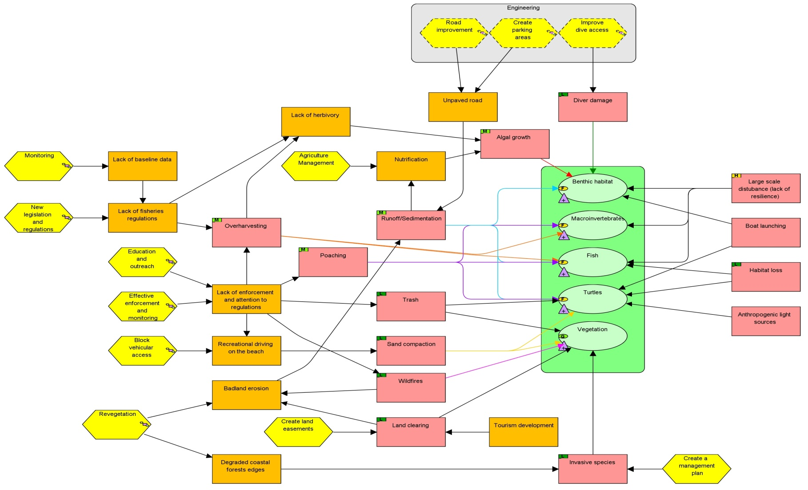
FIGURES
Figure 1: 2012 Laolao Bay Conceptual Model

Figure 2: 2012 Laolao Bay Results Chains
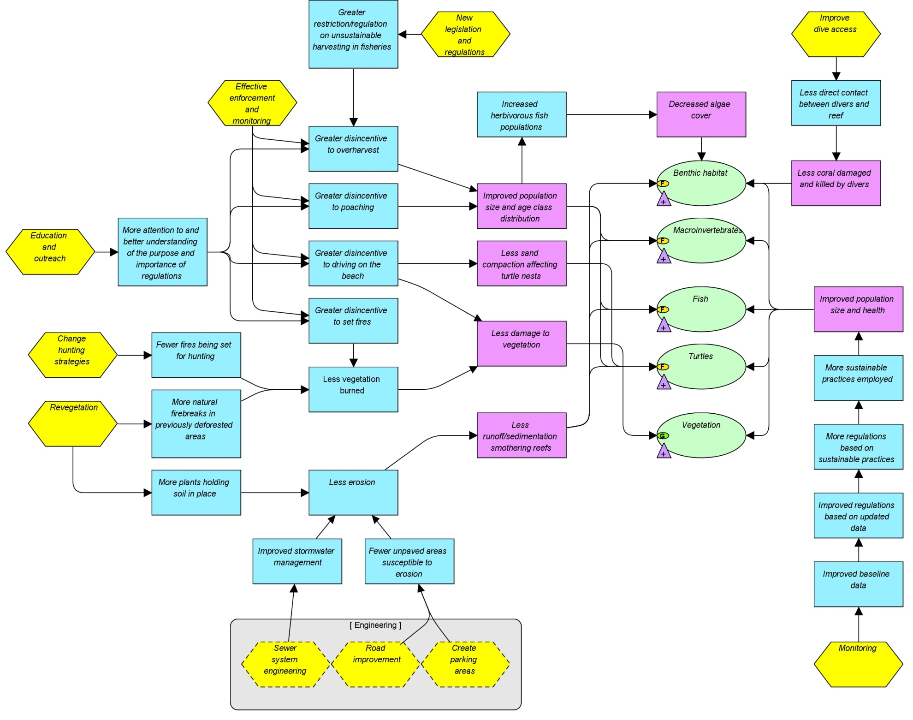

Appendices

Appendix 1: CAP Review Attendees (for February 28, 2012 meeting):
DEQ: Fran Castro, Kaity Mattos, Jose Quan, Jihan Buniag, Steven Johnson, Ryan Okano, Tim Lang
CRM: Rachel Zuercher, Dave Benavente, Rebecca Skeele
DFW: Jeremy Plauss-Johnson, Mike Tenorio, Joe Ruak
NOAA: Steve McKagan
NRCS: Jay Doronila
MINA: Sam Sablan, Frank Villagomez, Shirlynn Perez
PMRI: Greg Moretti
DPL: Pat Rasa, Mel Igitol
Marianas Variety: Tammy Doty

Appendix 2: Link to Technical Report comparing 1992 and 2010 Laolao Bay Marine Monitoring Data
- http://www.pacmares.com/home/wp-content/uploads/2013/05/Houk_et_al_2011_Laolao.pdf

