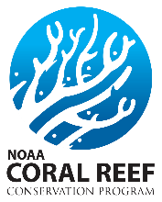
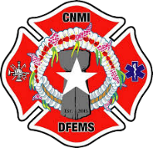
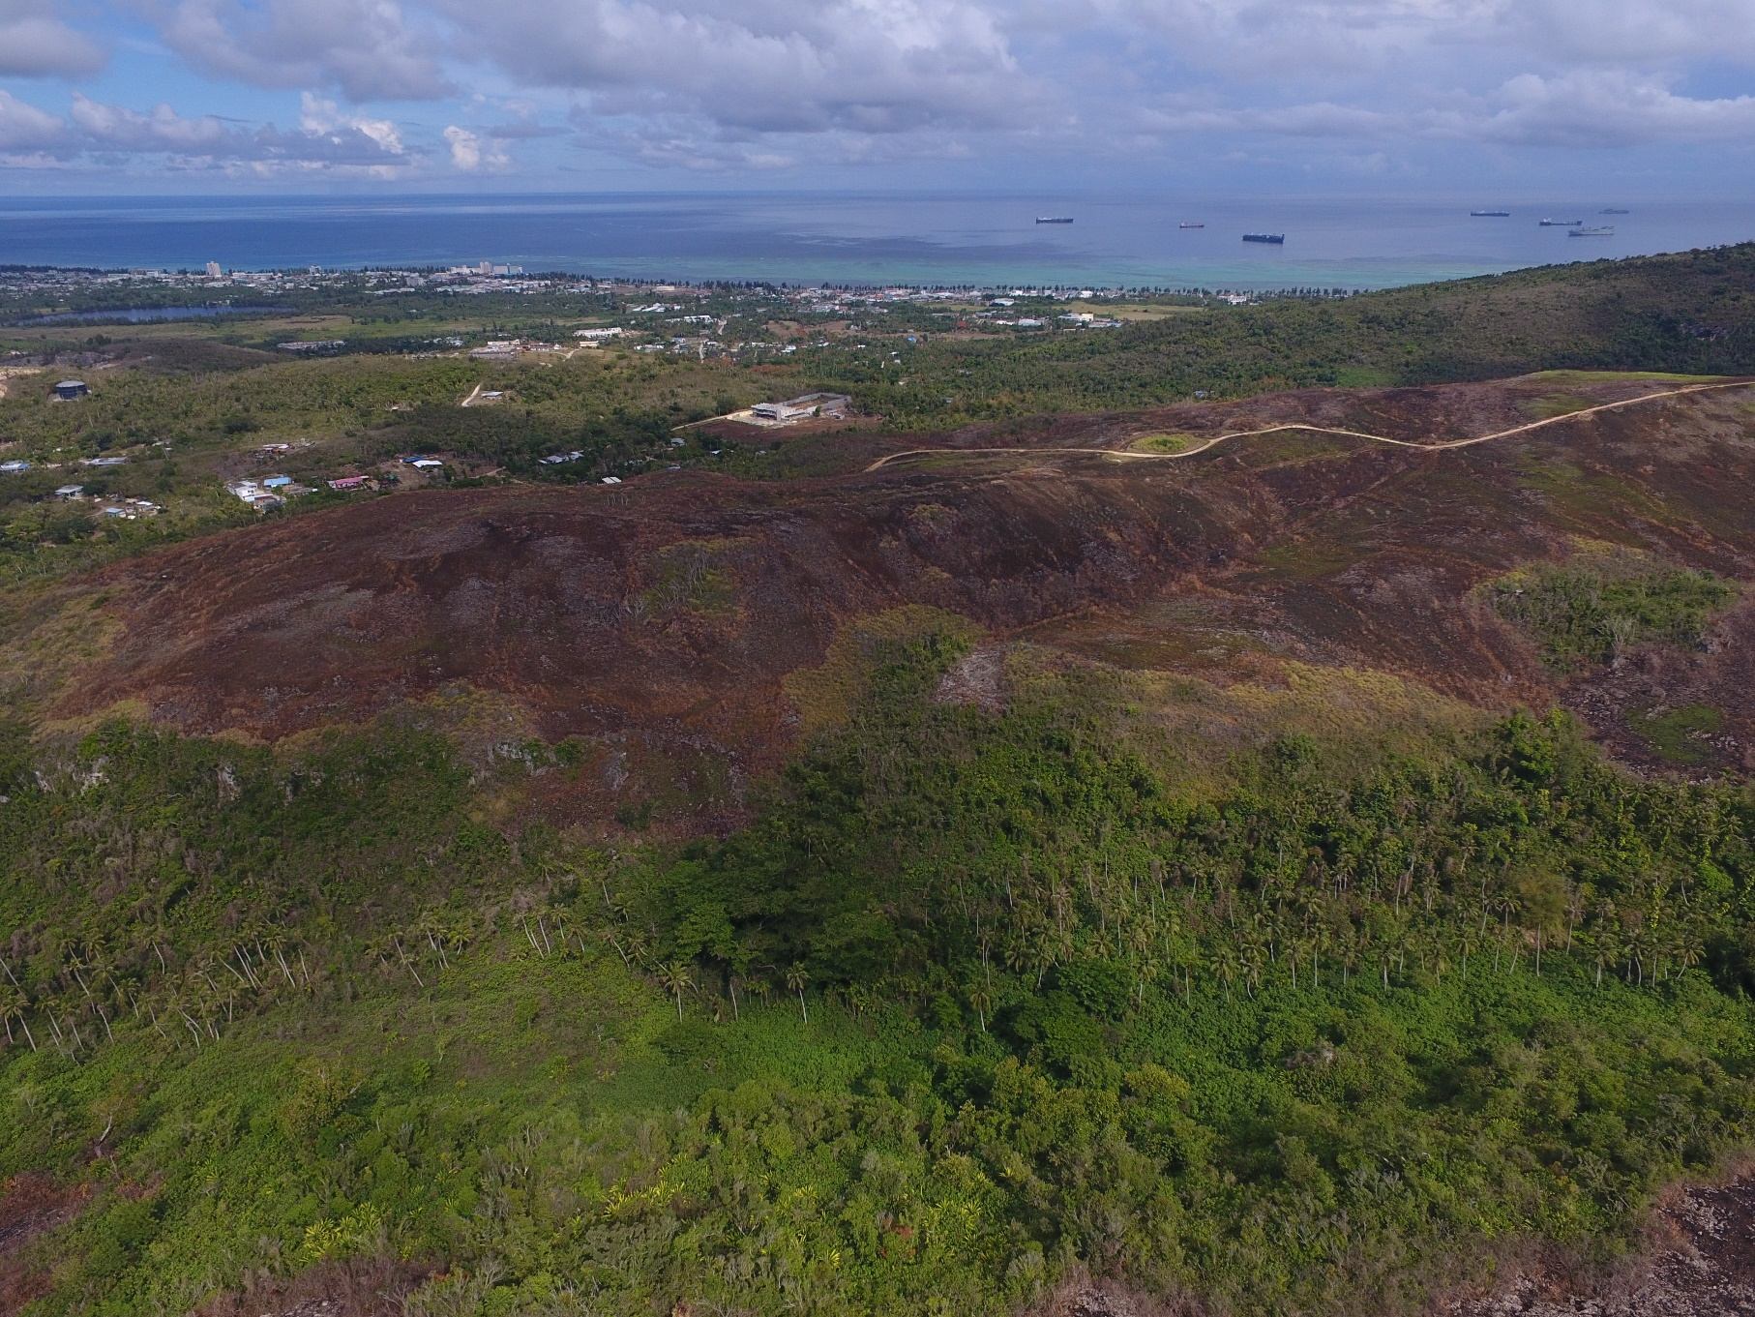
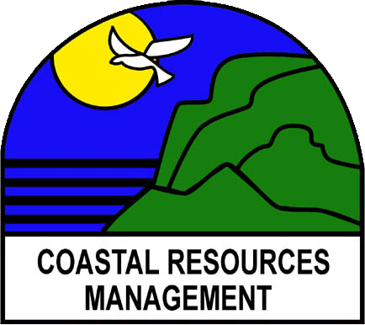
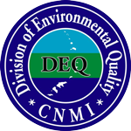
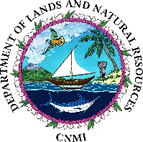
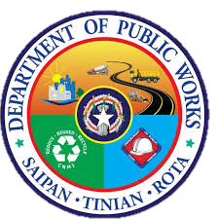
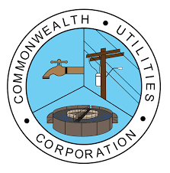
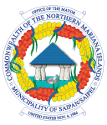
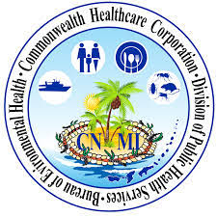
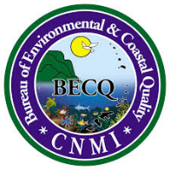
Saipan Fire Management Plan — 2021
Saipan, CNMI

Prepared for the CNMI Division of Coastal Resources Management by the NOAA Coral Fellow under the cooperative agreement award from the National Oceanic and Atmospheric Administration’s (NOAA) Coral Reef Conservation Program, U.S. Department of the Commerce. The statements, findings, conclusions, and recommendations are those of the author and do not necessarily reflect the views of NOAA, the NOAA Coral Reef Conservation Program or the U.S. Department of Commerce.
Author: Ilan Bubb
CNMI Bureau of Environmental & Coastal Quality (BECQ)
Division of Coastal Resources Management (DCRM)
Author: Ilan Bubb
00

Signature Page

The Saipan Fire Management Plan builds off previous management plans including the Standard State Hazard Mitigation Plan (2020) and State Wildland Fire Plan (2014). Goals and objectives in this plan were derived from a March 2020 workshop consisting of 20 stakeholders representing over ten different CNMI government agencies and NGO's. Research backing these suggestions were coalesced from exiting fire research pertaining to the greater pacific region along with Saipan-specific research completed in late 2020. Since the March workshop, additional talks, discussions, and research has been held to inform on fire management recommendations. This plan reflects a collaborative effort to improve watershed resilience to fires, reduce the total number of fires that occur on the island, and increase local knowledge of fire dynamics within the Commonwealth of the Northern Mariana Islands.

Approved by:

______________________________________________ __________________
DPW Director – James A. Ada Date

______________________________________________ __________________
Mayor of Saipan – David M. Apatang Date

______________________________________________ __________________
DEQ Director – Zabrina Shai Date

______________________________________________ __________________
DLNR Secretary – Tony Benavente Date

______________________________________________ __________________
BECQ Administrator – ELI D. Cabrera Date

______________________________________________ __________________
CUC Director – Gary P. Camacho Date

______________________________________________ __________________
OPD Director – Kodep Ogumoro-Uludong Date

______________________________________________ __________________
CHCC Chief Executive Officer – Esther L. Muna Date

______________________________________________ __________________
DCRM Director – Rich Salas Date

Acronyms and Abbreviations
AMP | American Memorial Park
APC | Area of Particular Concern
BECQ | Bureau of Environmental & Coastal Quality
BEH | Bureau of Environmental Health
BMPs | Best Management Practices
CAP | Conservation Action Plan
CID | Community Improvement District
CIP | Capital Improvement Project
CNMI | Commonwealth of the Northern Mariana Islands
CREES | Cooperative Research Extension & Education Service
CRI | Coral Reef Imitative
CSDP | Comprehensive Sustainable Development Plan
CUC | Commonwealth Utilities Corporation
DCRM | Division of Coastal Resources Management
DFEMS | Department of Fire & Emergency Medical Services
DEQ | Division of Environmental Quality
DFW | Division of Fish & Wildlife
DLNR | Department of Lands & Natural Resources
DPL | Department of Public Lands
DPW | Department of Public Works
FEMA | Federal Emergency Management Agency
FMP | Fire Management Plan
GCEA | Governor’s Council of Economic Advisors
GIS | Geographic Information System
HPO | Historic Preservation Office
HSEM | Homeland Security & Emergency Management
MINA | Micronesia Islands Nature Alliance
MOS | Mayor’s Office of Saipan
NMC | Northern Marianas College
NMFS | National Marine Fisheries Service
NOAA | National Oceanic & Atmospheric Administration
OPD | Office of Planning & Development
PDAC | Planning & Development Advisory Council
SCORP | Statewide Comprehensive Outdoor Recreation Plan
SSG | Smart, Safe, Growth

Table of Contents

Signature Page i
Acronyms and Abbreviations ii
Table of Contents iii
Executive Summary iv
Introduction 1
FMP Approach 2
Previous Fire Management Successes and Challenges 3
Existing Data Sources 4
Existing Monitoring Data and Ongoing Projects 5
Sustainable Development 5
Research and Baseline Data 5
Restoration 6
Community Engagement 6
Fire Ecology 7
Paleo-history 7
Modern Fire History 7
Insights on the Future of Fire 10
How Fires are started 10
Goals, Strategies, Objectives, Actions 12
Background 12
Key threats of fire 12
Goals, Smart Objectives and Activities 13
Monitoring and Evaluation Plan 18
Appendix A 21
Possible Locations for Revegetation 21
Appendix B 22
Right Light - Green Light 22

Tables and Figures

Figure 1 – Wireless Ridge................................................................................................... 1
Figure 2 – Fire Detections in Saipan .................................................................................. 6
Figure 3 – Line Graph of Precipitation ………………………………………………………….………………..7
Figure 4 – Chart of Precipitation vs Hectares Burned………………………………………….………….7
Figure 5 – Wetland Burn………………………………………………………………………………………….…….8
Figure 6 – Evidence of Fire Positive Feedback Loop……………………………………..………………..9

Table 1 – Fire documents, their source and date written................................................ 4
Table 2 – Ignition Sources ................................................................................................ 10
Table 3 – Social and Environmental Impacts of Fire ……………………………………..………………11
Table 4 – Education and Outreach Plan…………………………………………………………………….…..16
Table 5 – Monitoring and Evaluation Strategy ………………………………………………………………17

Appendixes

Appendix A ...................................................................................................................... x
Appendix B ...................................................................................................................... x

Executive Summary

As a key threat to coral health, fire has been a primary environmental concern for the Commonwealth of the Northern Mariana Islands (CNMI) for over a decade. As such the 2020–2021 Coral Fellow was tasked with developing a Fire Management Plan (FMP) that outlines steps to reduce the number of fires that occur on Saipan and increase the resilience of vulnerable watersheds. This FMP represents the amalgamation of the Fellow’s research, stakeholder input, workshops and previous management plans, coalescing to guide fire management for the next 10 years.

Since the last Wildland Fire Plan (2014) the CNMI has developed the ability to track wildfires and generate geospatial fire data through remote sensing. Because of this the CNMI now has a clearer understanding of where fires are occurring, when they are occurring, and the processes that contribute to their continued outbreaks across the Commonwealth. Using newly generated data as a baseline, a workshop was held on March 26, 2021 in which 20 stakeholders from ten key agencies and NGO’s gathered to discuss goals, objectives and actions that could be undertaken to reduce the impact that fires have on people and the environment. During the workshop key topics discussed included success and failures of previous management plans, social and ecological impacts of fires, barriers to management, management strategies, and division roles. Discussions were intended to develop a far reaching 10-year plan to address wildfires.

During the workshop four overarching goals were developed that would lead to reduced fire impacts:
- Establishing baseline fire data and understanding through:
  - Cataloging and determining different ignition sources
  - Expanding on the spatial and temporal fire analysis of the current Coral Fellow
- Reduce the amount of fire vulnerable lands through:
  - Establishing a long term revegetation methodology
  - Analyzing and documenting village specific risks
- Formalize coordination between relevant stakeholder groups through:
  - Creating a centralized database for all relevant fire data
  - Expanding the first iteration of the FMP to include Tinian and Rota
- Establish municipal trash collection through:
  - Developing education and outreach pamphlets on composting
  - Participating on the already established Governor’s Council of Economic Advisors (GCEA).

These four goals reflect the combined knowledge and experiences of workshop participants in regards to perceived social and environmental barriers, risks and threats, of fire as well as the barriers to managing it. In response to these barriers, risks and threats, the workshop reached a consensus that fire management will operate on three principles:
- Reducing ignition sources,
- Reducing fuel loads, and
- Increasing capacity to respond to active fires.
In this plan readers will be provided an overview of current fire management efforts and current research on CNMI fires. From this review the plan will go into the methodology behind its creation, a vision for what management of fires on Saipan will look like in the future, a detailed review of goals, objectives and actions created during the stakeholder workshop and finally a monitoring plan to be implemented throughout the next ten years.

Suggested Citation
CNMI Bureau of Environmental and Coastal Quality, Division of Coastal Resources Management. Prepared by: Ilan Bubb. 2020. “Saipan Fire Management Plan.” CNMI Division of Coastal Resources Management, CNMI Office of the Governor, Saipan, MP.

Contact
For more information, please visit the DCRM website (dcrm.gov.mp) or contact the DCRM Watershed Coordinator (watersheds@dcrm.gov.mp).

Introduction
Wildfires in the CNMI have been identified as an ecological and social threat in multiple Conservation Action Plans, Forestry Assessments, and academic journals (BECQ 2009, BECQ 2013, BECQ 2015, HSEM 2014, Bubb & Williams 2022. Since 2013, over 1,600 hectares of land have burned with some induvial fires burning more than 15 acres. Overall trends indicate that fires are becoming more frequent, larger in size and harder to control. Environmentally, fires harm coral reefs, degrade native forests, and spread invasive species (DCRM 2021). Socially, fires represent a threat to public health, burn infrastructure, and have the potential to result in a loss of life and income for the public. As such effective fire management is integral to the social and environmental health of Saipan (Bubb & Williams 2021, DCRM 2021).
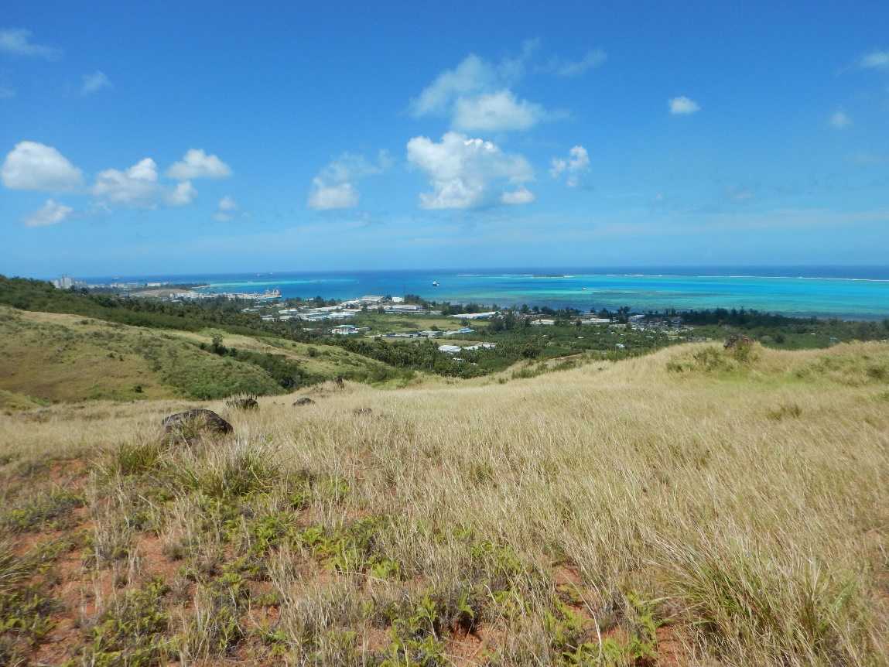
Fire management on Saipan is currently guided by outdated plans that rely on information that has been extrapolated from other Pacific islands and in general have a limited number of discreet achievable goals. The one document acting as a guide to fire management in the CNMI (State Wildfire Plan) was written in 2014 and explicitly identifies knowledge gaps as a hinderance to controlling fires. Furthermore, outside of secondary objectives in other management plans, there are few recommendations on specific actions that need to be taken to control fires (DLNR-Forestry 2014).
Figure 1: Wireless Ridge in the Achugao watershed is one of the most commonly ignited grasslands

Due to these problems, the 2020-2022 Coral Fellow for the CNMI was tasked to conduct research filling in known knowledge gaps relating to fire and use this research as the base for a Fire Management Plan (FMP). Within the Fellow’s scope of work, it was outlined that the new FMP would use current literature, new research and stakeholder meetings to produce a set of goals, objectives and actions that result in a reduction of the number of fires that occur yearly on Saipan. In addition, these goals would be achieved primarily though the collaborative effort of Bureau of Environmental and Coastal Management (BECQ) and Department of Fire and Emergency Medical Services (DFEMS), increasing inter-agency cooperation and data sharing.

FMP Approach
Action 1.5.1 of the 2019 CNMI Coral Reef Management Priorities provides the foundation for the FMP by calling for BECQ-Division of Coastal Resources Management (DCRM) to “Engage with DFEMs with developing a comprehensive wildfire mitigation and post disturbance response plan.” This, and multiple other plans including Watershed Management Plans (WMP), the State Wildfire Plan, and the Standard State Hazard Mitigation Plan all directly or indirectly call for the establishment of formalized management of fire within the CNMI. This FMP recognizes the previous work other stakeholders have completed and has incorporated and built on these works to create a comprehensive document that outlines the previous management goals and research, and introduces a new set of objectives that focus on fire management.
The FMP was developed through a multi-stage process. First, a literature review was conducted to identify specific knowledge gaps relating to fire management. This literature review showed that little was known about the spatial and temporal patterns of fire on Saipan and as a result management was difficult and ineffective. The literature review synthesized the current research and knowledge surrounding wildfires on Saipan from multiple different sources. It provided a reference for future management and provided guidance on what knowledge gaps existed as a barrier for effective policy. Information entailed comes from multiple sources including academic journals, government and university reports. While many of these sources are not fire-specific, they all contain sections dedicated to the current knowledge surrounding fire in the CNMI.
Using the literature review as guidance, the second step involved conducting research elucidating where, when and potentially why fires were occurring. The manuscript “Spatial and Temporal Patterns of Fire, Saipan CNMI (Bubb & Williams 2021)” utilized Landsat 8 imagery to identify burn scars on Saipan from November 2013 to June 2020. Using this methodology, the CNMI was able to identify which villages were most at risk for fires, what landcover type was most vulnerable to burning, how precipitation impacted fire risk and what months contain the most fires.
From here a workshop was held, gathering stakeholders to discuss fire management activities and outline agency capacity to partake in management. Planning for the multi-agency meeting took place months in advance with discussions between BECQ staff and other agency personnel. Communications included outlining items of discussion for the workshop, identifying stakeholders, and cataloging relevant documents and research to review before the meeting. During this period the CNMI Department of Lands and Natural Resources, Division of Forestry (DLNR-Forestry) started updating their Forestry Action Plan (FAP). The FAP was used as a reference to develop the different questions and talking points that could be addressed at the workshop.
On March 26th, 2021, 20 stakeholders from ten different agencies and NGO’s came together for a 1-day workshop pooling their experience and expertise to discuss feasible actions that would reduce the number of fires on Saipan. Three facilitators, including the Coral Fellow, the DCRM Coral Reef Initiative (CRI) Watershed Coordinator and the Outreach Specialist, helped organize the meeting and guide the stakeholders throughout the workshop. At the beginning of the meeting, participants were provided an overview of the current research and related management plans that were identified in the pre-meeting work as a primer the workshop’s discussions. Representatives from DFEMS, DLNR-Forestry, Micronesia Islands Nature Alliance (MINA), Northern Marianas College (NMC), and BECQ had the most experience with fires on the island. Stakeholders were put through multiple activities regarding their lived experience on Saipan and their perceptions of fire. These activities included:
- Devising a list of the immediate causes of fires;
- Mapping of historic fires on Saipan;
- Discussing the causes and impacts of fire on Saipan;
- Discussing existing barriers to effective fire management; and
- Developing 10-year goals, objectives and actions to manage fire in the long and short term.
Overall this process revealed patterns in how the community think fires start, the social and ecological issues that fires present, and the barriers to managing fire on Saipan. With this information the group was able to come together to develop the core goals, objectives and actions that the island could take to reduce the impacts of fires.

Previous Fire Management Successes and Challenges
Since 2009 when the first goals for fire management were outlined in the Laolao Conservation Action Plan (CAP), there have been some success at fire management in the CNMI.
- MINA and DCRM successfully implemented the Laolao bay restoration project which has planted native trees in vulnerable grasslands which should reduce fire risk.
- DLN_=Forestry has planted over 200,000 seedlings in the Talakhaya watershed on Rota, successfully reducing erosion and fire risk.
- DCRM has brought back the Watershed Warriors programing which includes lessons on fire ecology and methods to prevent fire.
- DCRM and MINA have started preparations a 6-acre grassland restoration project in the Achugao watershed aimed at reducing fires and erosion.
- Coordination between DCRM and DFEMS has increased resulting in a radio advertisement fire awareness campaign and fire warning signs being constructed across Saipan.
- A recent fire history of the CNMI has been established which shows where and when fires occur and offers a baseline to measure future fire management against.
Many barriers to successful fire management have been identified by local stakeholders. Overall these barriers fall under two large themes: lack of knowledge and lack of resources. Stakeholders have cited lack of community knowledge regarding fire prevention results in more cigarette and bonfire started fires. Additionally the lack of knowledge on fire patterns has resulted in poor management guidance and the absence of a baseline to monitor management success. The lack of resources has been linked to high turnover rate in various agencies, deficiencies in equipment personnel, and poor communication between agencies. This plan will help break down these barriers to further the CNMI’s fire management goals.

Existing Data Sources
The documents in Table 1 encompass all the current literature that reference fire on Saipan. These documents provide background ranging on the paleo-history of fire, fire ecology and current management of fire.
Table 1. Fire documents, their source and date written.
Document | Agency | Date Written
Talakhaya Watershed Management Plan (TWMP) | BECQ | 2017
Laolao Bay Watershed Management Plan (LWMP) | BECQ | In-Writing
Garapan Watershed Management Plan (GWMP) | BECQ | 2021
Spatial & Temporal Patterns of Fire on Saipan, CNMI | BECQ | 2021
Climate Change Vulnerability Assessment for the Island of Saipan | DCRM, Climate Change Working Group | 2014
Holocene Paleoenvironment of Saipan: Analysis of a Core from Lake Susupe | HPO | 2004
DLNR-Forestry Statewide Assessment & Resource Strategy | DLNR-Forestry | 2010
State Wildland Fire Plan | DLNR-Forestry | 2014
Standard State Mitigation Plan | HSEM | 2014
Assessing Fire Management Needs in the  Pacific Islands: A Collaborative Approach | University of Hawai’i, US Forest Service | 2018
Rainfall Climatology for Saipan | WERI | 2004
Coral Reef Management Priorities | BECQ | 2019
Comprehensive Sustainable Development Plan | OPD | 2021
Smart, Safe Growth | OPD | 2021
Only two documents in the above table are explicitly about fire in the CNMI. The State Wildland Fire Plan written by the DLNR-Forestry in 2014 provides a concise overview of fires on Saipan but is hindered by the fact that many of its maps and data are unsourced and illegible due to size. It is also outdated as evidenced by the omission of current conservation projects such as the Laolao revegetation site. BECQ’s Spatial and Temporal Patterns of Fire document provides the most up to date description of fire on Saipan. It is also to be noted that many of the other documents also contain data that are source-less or without citation making their use limited. Additionally, the Laolao Watershed Management Plan (LWMP) and Comprehensive Sustainable Development Plan (CSDP) are the only documents with explicit goals relating to fire.

Existing Monitoring Data and Ongoing Projects

Sustainable Development
As mentioned above, the CDSP is the CNMI’s primary document guiding future sustainable development on Saipan. Through years of workshops, stakeholder groups, and community meetings, the CDSP has been crafted to promote the social-environmental-economic development of Saipan in an equitable and just method utilizing the UN’s Sustainable Development Goals (SDG) as a framework. Under SDG 15, the CDSP states that “By 2022, BECQ develops a Wildfire Management Plan that addresses planning, response and mitigation of wildfires to support efforts to reduce human induced wildfire, and by 2025 the amount of man-made wildfires is reduced by 50% in area.” It is still to be determined what baseline number will be used to measure the success of reducing fires by 50%.
The implementation of the Smart, Safe Growth is currently aiding in project development across the island. This tool will soon be offered as an online application that will allow users to generate a report showing possible areas for more sustainable development.

Research and Baseline Data
Fire monitoring is being conducted by DCRM utilizing Landsat 8 data to detect medium to large scale fires. This is being done with the same methodology that Bubb & Williams (2021) used to detect fires. In addition, DFEMS is currently collecting GPS points for every fire that they respond to and putting them into a database. Lastly, the University of Hawaii Fire Monitoring Program regularly updates fire maps of the CNMI using WorldView Satellite imagery. This data is not posted online but is available upon request.
Three weather stations have been erected across Saipan. Monitoring stations exist at the airport, Capitol Hill, and Laolao Bay restoration site. These stations are collecting continuous climate data including rain levels, wind speeds and pressure changes. Only the airport and Capitol Hill gauges are outputting publicly available datasets.

Restoration
Two large grassland restoration projects are occurring on Saipan. The Laolao Bay restoration program is currently in the maintenance phase after over xxx native trees have been planted. There is no available data to determine the impact that this project has had on preventing fires, although anecdotally, no fires have occurred in the restoration area since the project started. Currently a restoration project in Auchago is underway to restore 6-acres of degraded grasslands. The goal of this project is to facilitate the reduction of flammable grasses and replace them with native, fire resistant-trees.

Community Engagement
A Saipan-wide fire education and outreach program is underway. The Watershed warriors program has is being implemented at Gregorio T. Camacho Elementary, with lessons on watershed and fire management. This program will start its second session in the Spring of 2022; DFEMS was integral in this project to garner by-in for the original grant and to teach a lesson on wildfire management. DCRM, in collaboration with DFEMS, has started putting up fire awareness signs designed to spread fire management guidelines to the public as well as display the islands current fire risk (Appendix B). Lastly, newspaper and radio ads printed/aired around holidays associated with fireworks reminding citizens to be careful with sparks and embers during the dry season.

Fire Ecology

Paleo-history
Stevens and Ward (2004) elucidates the paleo-history Saipan though sediment core surveys. This study reveals two important patterns. First, that charcoal did not appear in the sediment record until approximately 4,800 years ago, and second that concentrations of invasive grass pollen grains and charcoal particulates increase over time concurrently. The first pattern shows that the appearance of fire in the sediment record coincides with the arrival of the first humans. This concurrence implies that fire was not a part of the natural ecology of Saipan and only began to occur commonly as human disturbances expanded. The second pattern provides evidence that grasslands either formed or expanded at the same time as fires started. Although causation cannot be proven, this evidence suggests some sort of dynamic between the increasingly common fires and the expansion of grasslands on Saipan.

Modern Fire History
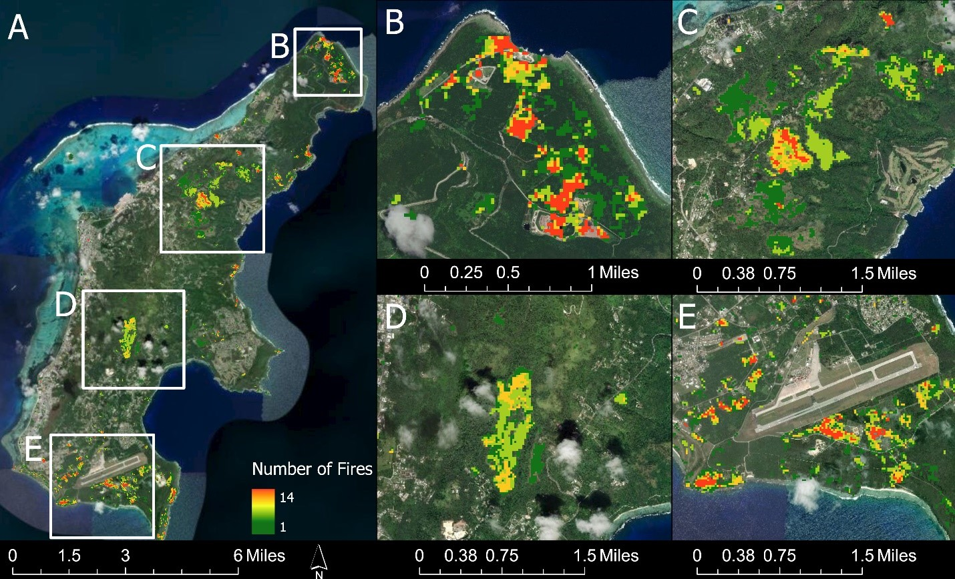
Contemporary fire ecology is most completely described by the manuscript, “Spatial and Temporal Patterns of Fire, Saipan” (Bubb & Williams 2021). Using remote sensing techniques, fires are shown to be an extremely common modern phenomenon in which 1,600 hectares burned between the years 2013–2020. From this analysis, four hotspots were found on Saipan that represent the location for the majority of wildfires: Wireless Ridge, south of Mt. Tapochao, Marpi, and the grasslands south of the airport.
Figure 2: Fire Detections on Saipan between 2013 and 2020; four hotspots are shown in panels B through E. (Bubb & Williams 2022)

The paper also supported local perceptions of the temporal patterns of fire. The analysis showed that fires were almost non-existent during the rainy season and peaked in the middle to late dry season after vegetation was dried out. It also suggests that fires become more frequent during periods of intense drought, as evidence by their spike in 2019 and 2020 (years with lower than average precipitation).
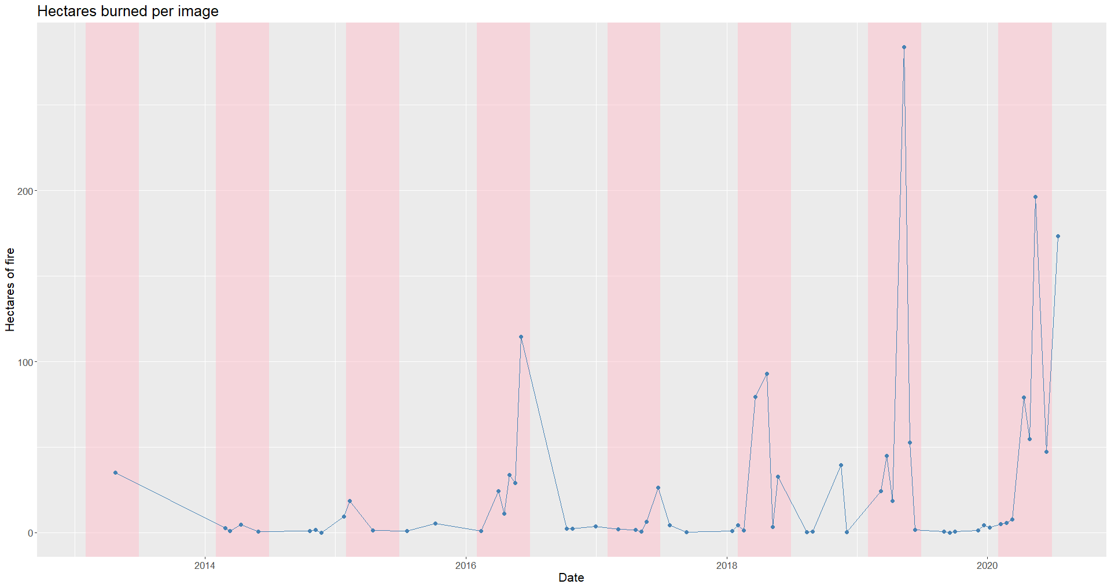
Figure 3: This chart was taken from Bubb & Williams 2022 and shows the amount of fire detected throughout the study period.

Analyzing precipitation data suggests that there is a high correlation (r_{s} = -0.7) between rain and fires — as rainfall decreases the amount of fire increases. Additionally, as the number of days with low levels of precipitation (>1mm) increases, so does the amount of fire. This provides evidence to show that precipitation is one of the most important factors for controlling fire on Saipan. While the connection between rain and fire is intuitive, this manuscript helps identify the magnitude of these correlations and will form the base of the fire warning guidelines discussed later in the plan and Appendix B.
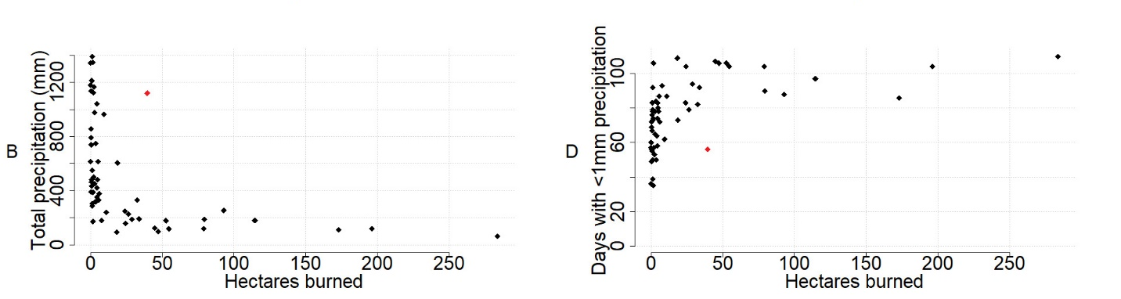
Figure 4: This chart was taken from Bubb & Williams 2022 and shows the relationship between rain and fire

Landcover types that consist of vegetation vulnerable to drought are the most impacted by fires. Grasslands, shrub, and pasture all contain flora that desiccate during the dry season and become easily ignitable by small embers. In contrast forests, especially native limestone forests and wetlands, appear to be the least vulnerable as they are comprised of large, succulent vegetation that hold more water. It is to be noted that these landcovers can still burn during intense droughts or by large fires (Fig. 5).
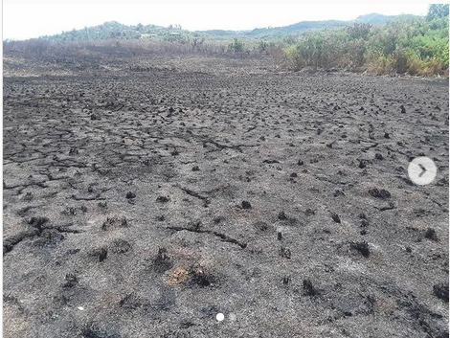 | 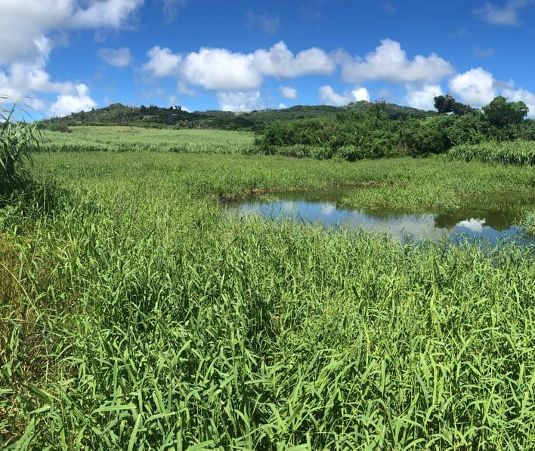
Figure 5: Pictures taken of Kagman wetland. First image shows the result of a burn in the 2020 dry season while the second shows recovery after three months.

Lasty there is mounting evidence that fires start a positive feedback loop that facilitates the conversion of forests into grasslands. Fires typically ignites in grasslands where the vegetation is the most flammable. During these fires the flammable grasses and shrubs carry a flame until it reaches the grassland-forest boundary that acts as a fire break. While these fires are typically not strong enough to penetrate far into the forest, a couple of meters of the forest vegetation will die to heat and scorching. In these few meters, grasses can outcompete the slower growing forest species converting the former forest into grasslands. Over time repeat burns will result in ever expanding grasslands and degrading forests. This is pattern is especially important within the larger grasslands such as on Wireless Ridge and Mt. Tapochau which are comprised of many individual grasslands separated by thin forest boundaries. As these forests are burned away connections between the grasslands may form, allowing for bigger and more expansive fires that were previously impossible due to the forest breaks.
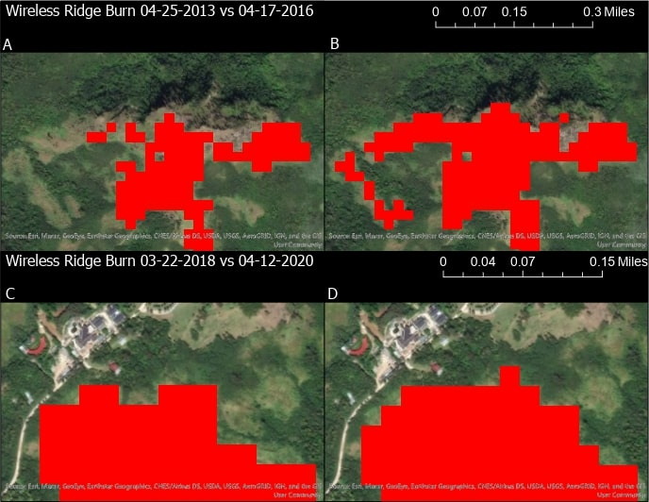
Figure 6: The image above is taken from Bubb & Williams 2022 and provides two examples in which repeat burns resulted in larger subsequent fires.

Insights on the Future of Fire
The CNMI’s Climate Change Working Group points out that Saipan is expected to have increased rain during the wet seasons and decreased rain during the dry seasons due to the effects of climate change. This will likely have a profound impact on fire in the future as less rain is correlated to higher amounts of fire. Additionally, a greater amount of rain during the wet season can facilitate more growth in grass which has the potential to fuel bigger fires in the next dry season. Insights on the effect that increased precipitation seasonality will have on Saipan can be seen from other pacific islands. Islands that have stronger distinctions between rainy and dry seasons also have greater coverage of grasslands and more frequent fires (Trauernicht et al. 2015, personal communication.)

How Fires are started
There has been no definitive study about how fires are started in Saipan. Much of the current information comes from different on-island sources such as DFEMS, BECQ and locals. When asked about how fires are regularly started a myriad of answers are given and these can be separated into categories ranging from most likely to least likely to start a fire. Since there is no research backing these separations, placement is based on field observations and conversations with DFEMS.
Table 2: Fire ignition sources.
Cause of Fire | Likelihood | Source
Lit Cigarettes | Confirmed | DFEMs & Direct Observation
Trash Burning | Very Likely | DFEMs
BBQ/Cooking | Very Likely | Multiple
UXOs | Likely | Multiple
Ambient Car Heat | Likely | DFEMs
Lightning | Unlikely | Multiple
Light Magnification | Very Unlikely | OPD
Spontaneous Combustion | Very Unlikely | Multiple

All of the sources listed above have the potential to start a fire when combined with dry grass and other vegetation. Lit cigarettes however are the only source that have been directly confirmed to start a wildfire on Saipan. Other stakeholders feel confident that trash burning and outdoor cooking are very likely to be the cause of fires due to the presence of a flame and the known ability for wild fires to spread by ember, even if not observed directly. Cars have been observed parked on tall grass in various locations and have the potential to be hot enough to ignite grass in the right conditions. UXOs have also been identified as potentially starting fires. While UXOs are commonly found among the grasslands, they are more likely to explode in response to an ongoing fire instead of starting one itself. Because of this UXOs might be more responsible for the spreading of fire instead of starting one. Lightning has also been mentioned as a possible source for fires and is a well know source in many parts of the world. However due to the climate and structure of the island, lightening is a relatively uncommon phenomenon over Saipan. Additionally, when lightening does occur it, most often coincides with wet season which makes the ignition of grasses less likely. The last two sources of fire in the table have the least amount of evidence from field work and from literature. Light magnification supposedly occurs when a shard of glass in a grassland focuses sunlight much like a magnifying glass. While this is theoretically possible it is highly unlikely as the glass would usually be on the ground shaded by the taller grasses. Spontaneous combustion has been brought up multiple times but with no evidence from any agency. When discussed it is often talked about in conjunction to landfills and other trash sites possibly implying some sort of relation between the gasses or other chemicals released by the trash and spontaneous fire.

Goals, Strategies, Objectives, Actions

Background
During the Fire Management Plan workshop hosted at the Hyatt, representatives from 10 different local agencies came together to discuss threats of fire, barriers to fire management and to develop goals, strategies, objectives, and actions to reduce the number of and impact of fires.

Key threats of fire
As a group attendees were divided into two groups to discuss the ecological and social effects of fire. The following is a summary of these group’s discussions.
Table 3: The social and ecological effects of fire generated from the Fire Management workshop
Social Effects | Ecological Effects
Loss of Life/Property  - Fire has the potential to burn housing, landscapes and property.  - In extreme cases wildfires have been big enough to result in death without intervention of DFEMS | Erosion  - Loss of vegetation will result in increased erosion. Frequent fires can result in badlands that have no vegetation cover and are perpetually under threat of erosion.
Reduction of Health and Safety  - Fires can have large impacts on agricultural fields impacting local food supply.  - Smoke from burning debris is a known health hazard. | Increased Water Flow  - Increased water flow from reduction of vegetation reduces the amount of water infiltration into the aquifer.  - Increased water flow can result in more pollutants being carried into water ways and eventually the ocean.
Loss of Aesthetic Landscapes  - Large burn scars are unsightly and can contribute to the degradation of Saipan’s  - scenic landscape. | Habitat Loss  - Fires have a detrimental impact on forests where many endemic and endangered species live.  - As forests are burned, invasive species will be able to replace them resulting in the spread of savannas.  - As native forests are reduced and savannas spread, biodiversity will be replaced with low biodiverse savanna vegetation.
Loss of Livelihoods/Income
- Fires can impact agricultural lands leading to loss of income for farmers or other cultivators.
- Reduced water quality and coral cover can impact fisher communities forcing them to spend longer times in the field or wiping out target species.
- Reduction in scenic views and marine life can detrimentally impact tourism putting a strain on hotel and resort and the people this industry employs.
Reduction in Community Harmony
- Human started fires can result in a “blame game” among community members resulting in increased social strife.
Strain on Public Resources
- Larger and more frequent fires will require stronger responses during and post-fire, resulting in an increased strain on DFEMS and infrastructural repair budgets.

Goals, Smart Objectives and Activities
Participants were separated into two groups to develop 10-year goals that would result in the reduction of the number and impact of fires. From these discussions over 20 goals were suggested. A voting process with established were everyone was able to vote for three of these goals to be included in the final management plan. The four goals that received the most votes are as follows:
- Increased institutional understanding of fires on Saipan
- Reduction in fire vulnerable lands
- Establish municipal trash collection
- Formalize coordination of relevant stakeholder groups

The following objectives and activities were developed in order to support the four 10-year goals. All will directly contribute to reducing the frequency and impact of fires on Saipan.

Goal | Objective/Activity | Funding Required | Partners and Technical Assistance Required
Goal 1 | Objective One:  By 2025, baseline fire data and understanding established and published in formal report.
 | Activity 1.1  Survey agencies to collect already available fire data/info while determining data gaps. | $0 | Lead: BECQ
 | Activity 1.2  Fire data is published in a peer-reviewed manuscript for future management | $0 | Lead: BECQ
Objective Two:
By 2022, establish multi-agency protocol for wildfire monitoring
 | Activity 2.1  Establish agency roles in the Fire Monitoring protocol. | $0 | Lead: BECQ  Partners: OPD
 | Activity 2.2  Continue automated Landsat fire delineation | $0 | Lead: BECQ
Objective Three:
By 2022, outreach incorporating multi-stakeholder messaging targeting fire prone areas/villages
 | Activity 3.1  Determine and develop village specific fire concerns through talks with DFEMS and BECQ. | $1,000 | Lead: BECQ & DFEMS
 | Activity 3.2  Build fire risk signs that target different areas of the island reflecting that specific locations risk. | $7,000 | Lead: BECQ & DFEMS
 | Activity 3.3  Develop radio/newspaper ads that can be released before the start of dry season, and before holidays associated with fireworks. | $5,000 | Lead: BECQ

Goal | Objective/Activity | Funding Required | Partners and Technical Assistance Required
Goal 2 | Objective Four:  By 2022, reforestation at rate of 1 acre planted per year on identified vulnerable lands
 | Activity 4.1:  Identify sustainable funding source for nursery outside of current Achugao grant. | $0 | Lead: Forestry  Partners: BECQ
 | Activity 4.2  Identify public lands that are available for restoration activities. | $0 | Lead: BECQ
 | Activity 4.3  Develop ongoing nursery at Forestry for restoration out planting. | $10,000 | Lead: Forestry
 | Activity 4.4  Test banana trees as a fire resistant restoration plant. | $1,000 | Lead: Forestry
Goal 3 | Objective Five:  By 2030, municipal trash collection service for green and household waste is accessible to 100% of Saipan’s population
 | Activity 5.1  Have FMP Representative on GCEA | $0 | Lead:
 | Activity 5.2  Develop outreach material to encourage community shift from burning trash to throwing it away. | $1,000 | Lead: BECQ
Objective Six:
By 2030, 50% of waste is diverted from landfill through zero waste initiatives
 | Activity 6.1  Develop and distributable brochure on how to compost in your backyard | $1,000 | Lead: DEQ

Goal | Objective/Activity | Funding Required | Partners and Technical Assistance Required
Goal 4 | Objective Seven:  By 2030, an open access database containing spatial data, management plans, and other pertinent statistics relevant to fire management is created
 | Activity 7.1  Determine which department is capable of hosting and creating the database | $0 | Lead: OPD
Objective Eight:
By 2023, Expand Saipan Fire Management plan to include Tinian and Rota creating the CNMI Comprehensive Fire Management Plan.
 | Activity 8.1  Meet with Tinian/Rota Forestry/BECQ representatives to discuss FMP | $0 | Lead: BECQ OPD
 | Activity 8.2  By 2023, an MOU is effectuated between BECQ, OPD, DFEMS, DLNR, DPW, CUC, CHCC, DCCA, MOS and other community partners to implement fire management plans across departments and islands | $1,000 | Lead: BECQ OPD

Education and Outreach Plan
Target Audience | Which Objective is This Tied Too? | Key Messages | Outreach Strategy | Outreach Materials Needed | Who will track progress?
Residents | 3,5,6 | Methods to mitigate home/property from fire damage.  How to prevent fires from occurring during the dry season. | Watershed Warriors, Signage, Factsheets, newspaper and radio ads. | Stickers, presentations, ready to release ads, signage | BECQ
Hunters | 3,4 | Burning grasslands can cause damage to watersheds and habitat.  Intentionally setting fires to public land is illegal. | Signage, stickers, real hunters don’t burn materials. | Stickers, education materials including pamphlets | BECQ
Agricultural Workers | 3,4 | How to conduct controlled burns on property. | Educational material | Pamphlets | NCRS
CNMI Policy Makers | 1,2,5,6,7,8 | Fire impacts watershed aesthetics and coral health, which impacts tourism.  Strategies to mitigate fires along with their costs. | Fire Management Plan creation and discussions | Summary of Management Plan | BECQ, OPD
DFEMS | 1,2,3,7,8 | Strategies to mitigate fires.  How to keep track of fire monitoring data. | Continued inter-agency coordination. Fire Signage | Summary of Management Plan, fire maps. | DFEMS, BECQ
DCRM & DFW Enforcement Officers | 1,2 | Fire regulations. | Training Sessions for Enforcement Officers | Legal Code | BECQ, DFW
DLNR-Forestry | 1,2,4,7,8 | What plants are most effective at preventing fire?  Which areas are most fire vulnerable to guide out-planting? | Continued knowledge sharing between DLNR-Forestry and BECQ | Fire Maps, and nursery | BECQ, Forestry
Table 4: Education and Outreach Plan

Monitoring and Evaluation Plan
The following section outlines what and how the CNMI will track the objectives and goals outlined above come. Current fire monitoring is limited to an automated Python script that identifies burn scars from Landsat imagery, and from DFEMS GPS points collected after responding to fires. There is little evaluation of the success of already implemented management strategies including the Laolao revegetation project, watershed warriors, radio ads, and newspaper ads. Monitoring will be a core part of the implementation of the FMP, to evaluate the success of various initiatives and track progress of others.
Table 5: Monitoring and Evaluation Strategy
Objective/Activity | Date of Completion | Indicator of Progress | Who will Track
Objective One:  By 2025, baseline fire data and understanding established and published in formal report. | 2025 | Report is published  Baseline data is continually generated
Activity 1.1  Survey agencies to collect already available fire data/info while determining data gaps. | June 2022 | # of agencies surveyed
Activity 1.2  Public data in a peer-reviewed manuscript for future reference management reflections | January 2022 | Manuscript is published
Objective Two:  By 2022, establish multi-agency protocol for wildfire monitoring. | January 2022 | Protocol is developed
Activity 2.1  Establish agency roles in the Fire Monitoring protocol. | January 2023 | # of agencies with ascribed roles
Activity 2.2  Continue automated Landsat fire delineation | January 2022 | # of Landsat images processed
Objective Three:  By 2022, outreach incorporating multi-stakeholder messaging targeting fire prone areas/villages | 2022 | # of signs created  # of newspaper ads published  # of radio ads aired
Activity 3.1  Determine and develop village specific fire concerns through talks with DFEMS and BECQ. | January 2023 | # of villages analyzed

Objective/Activity | Date of Completion | Indicator of Progress | Who will Track
Activity 3.2  Build fire risk signs that target different areas of the island reflecting that specific locations risk. | June 2022 | # of signs built
Activity 3.3  Develop radio/newspaper ads that can be released before the start of dry season, and before holidays associated with fireworks. | June 2022 | # of ads aired  # of newspaper ads published
Objective Four:  By 2022, reforestation at rate of 1 acre planted per year on identified vulnerable lands | 2022 | Was an acre of forest planted
Activity 4.1:  Identify sustainable funding source for nursery outside of current Achugao grant. | January 2024 | Was a source found
Activity 4.2  Identify public lands that are available for restoration activities. | June 2022 | Map created showing possible revegetation sites
Activity 4.3  Develop ongoing nursery at Forestry for restoration out planting. | June 2022 | Nursery is created
Activity 4.4  Test banana trees as a fire resistant restoration plant. | January 2023 | # of bananas planted
Objective Five:  By 2030, municipal trash collection service for green and household waste is accessible to 100% of Saipan’s population | 2030 | Percentage of households with garbage collection
Activity 5.1  Have FMP Representative on GCEA | June 2022 | Is member on the council
Activity 5.2  Develop outreach material to encourage community shift from burning trash to properly disposing of it. | January 2023 | # of outreach materials developed

Objective/Activity | Date of Completion | Indicator of Progress | Who will Track
Objective Six:  By 2030, 50% of waste is diverted from landfill through zero waste initiatives | 2030 | Percent of waste diverted from landfill based on OPD landfill analysis
Activity 6.1  Develop and distributable brochure on how to compost in your backyard | January 2023 | Brochure is developed
Objective Seven:  By 2030, an open access database containing spatial data, management plans, and other pertinent statistics relevant to fire management is created | 2030 | Database is created
Activity 7.1  Determine which department is capable of hosting and creating the database | January 2022 | Department is determined
Activity 7.2  Determine what data each agency wants to host in shared database | January 2023 | # of departments surveyed
Objective Eight:  By 2023, Expand Saipan Fire Management plan to include Tinian and Rota creating the CNMI Comprehensive Fire Management Plan. | 2023 | Plan is extended to Tinian and Rota
Activity 8.1  Meet with Tinian/Rota Forestry/BECQ representatives to discuss FMP | June 2022 | Meeting on how to include other islands has occurred
Activity 8.2  By 2023, an MOU is effectuated between BECQ, OPD, DFEMS, DLNR, DPW, CUC, CHCC, DCCA, MOS and other community partners to implement fire management plans across departments and islands | January 2023 | # of agencies signed onto MOU

Appendix A

Possible Locations for Revegetation
The map below shows the overlap of public lands as designated by BECQ’s 2017 parcel dataset and documented fires. This map suggests that revegetation efforts might best be focused on the large public lands that are vulnerable to fire around Capital Hill. By virtue of these areas being public lands, less permitting and by-in will be needed to start any conservation effort. In addition, these fires are some of the largest and most commonly lit suggesting that conservation efforts here will have the most impact.
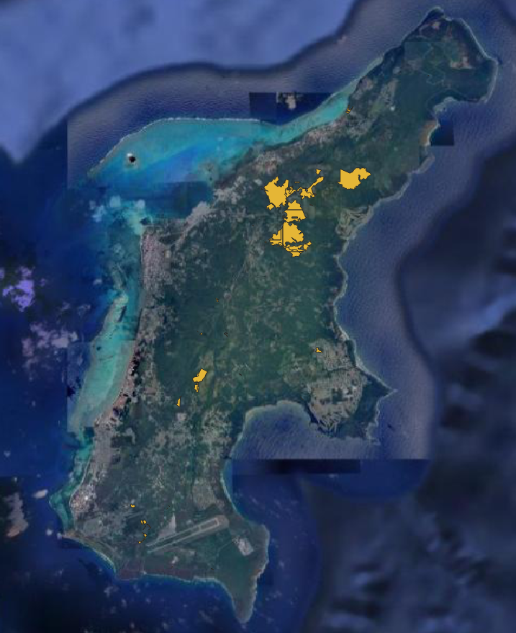

Appendix B

Right Light - Green Light
As signs are constructed across Saipan to provide educational material on different aspects of fire, they will also have slider bars to indicate the current threat level of fires igniting. This threat level will best be predicted by the amount of rainfall that occurred in the previous 100 days. With four different levels of fire threat we can break risk into the following chart
Risk Level | Total Precipitation
Level 1 | 114mm
Level 3 | 70mm
Level 4 | 55mm
Level 5 | 40mm

